**Relational database services**



**Types of Databases and examples:**

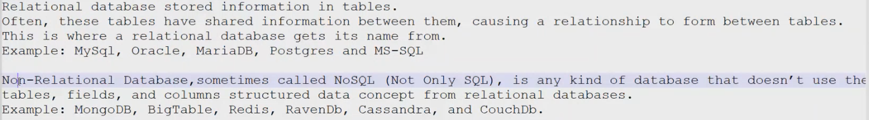

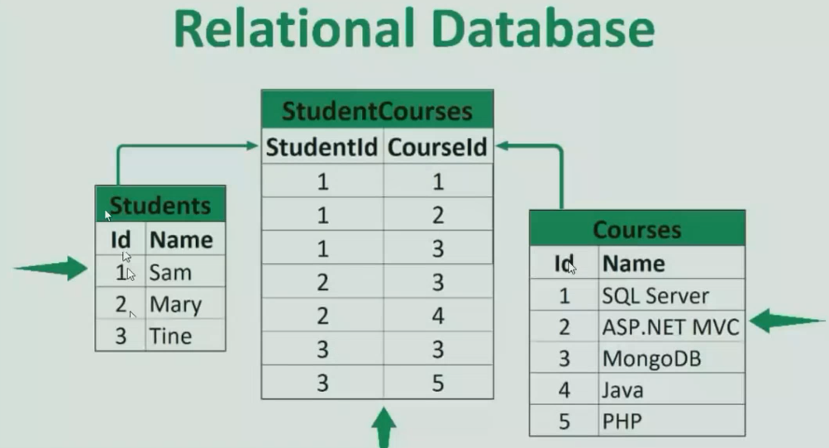

**“AWS SUPPORTS RELATIONAL DATABASE”**

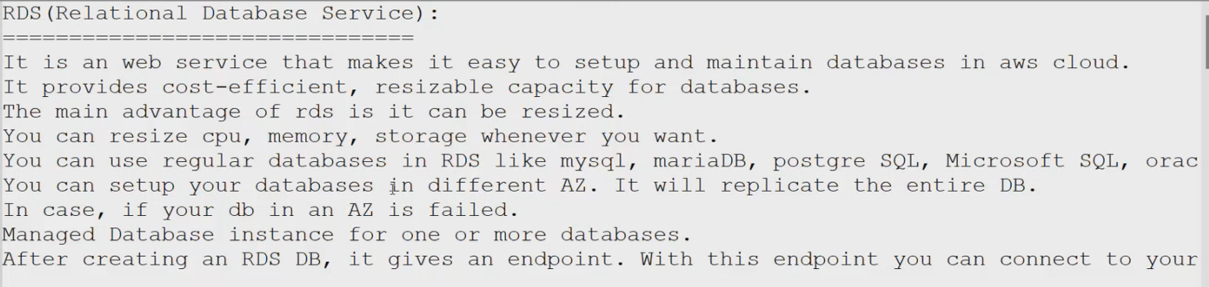

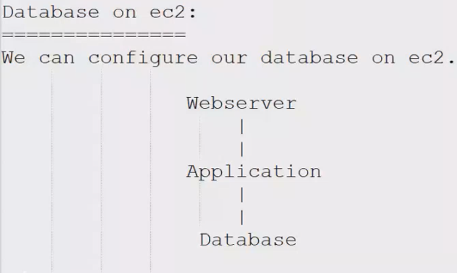



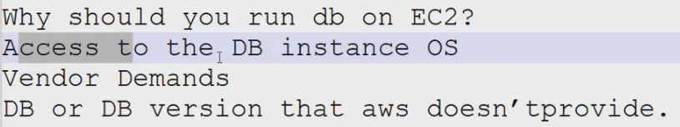

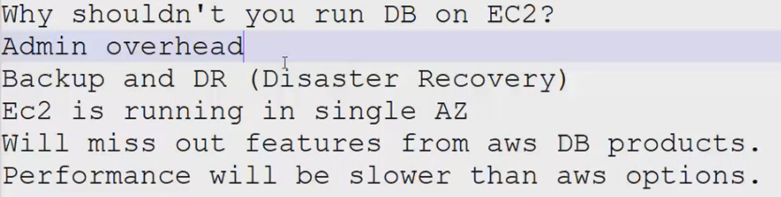

**INSTALATION PROCESS :**

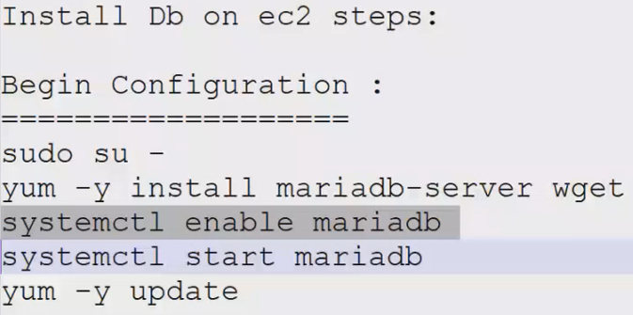

**AFTER INSTALLING WE CAN ONLY CHECK BY PORT NO.3306/TCP**

**“SQL : STRUCTURAL QUERY LANGAUAGE”**

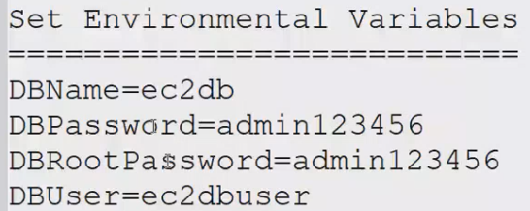

**“THESE ARE TEMPORARY STORAGE IF WE RESTART THE PROCESS THE STORAGE OF ENV WILL BE GONE”**

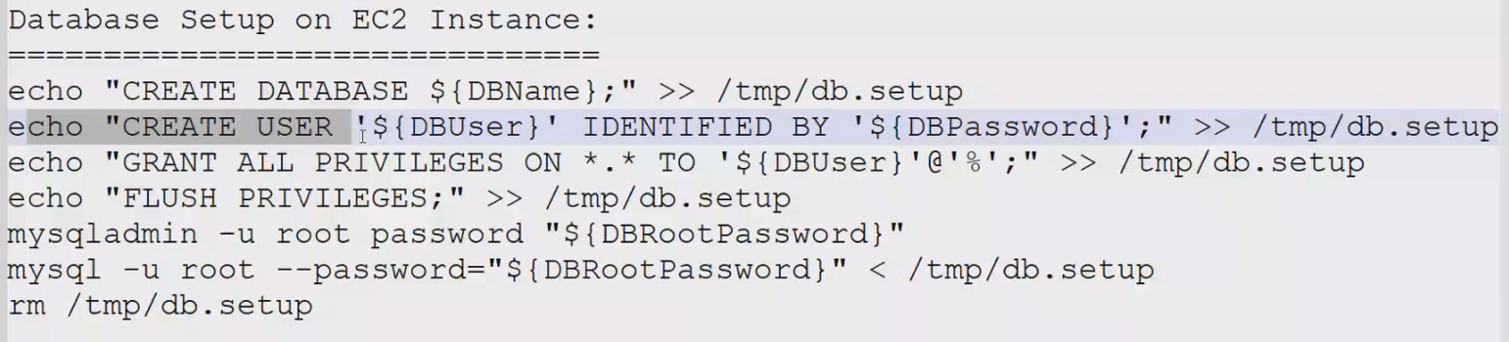

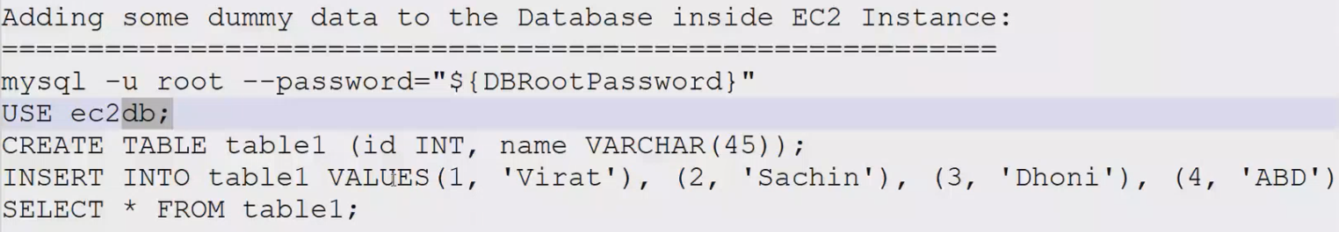

**1.** **Creating Maria-db database on ec2;**

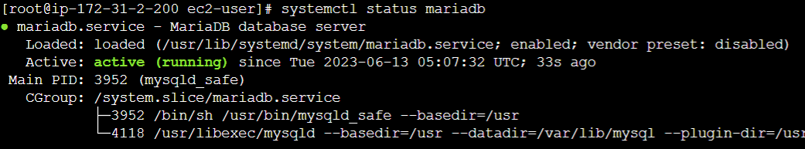

**SQL run on “3306” port only;  
**

**After that we have to give some Env. Variable;  
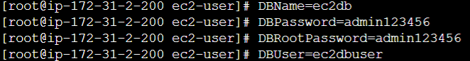**

**“This are only temporary variables”**

**Database Setup on EC2 Instance:**

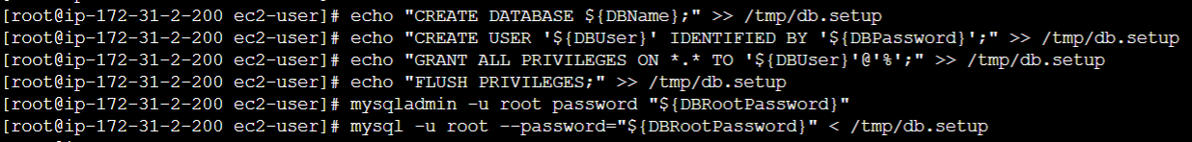

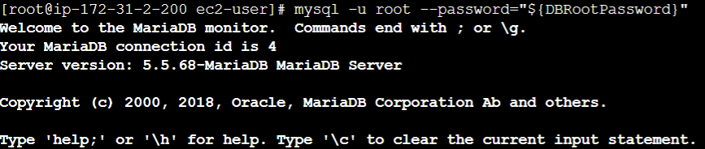

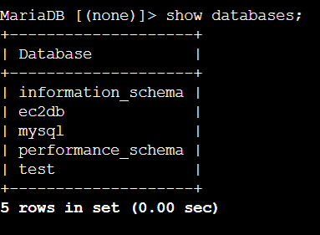

**2. Adding some dummy data to the Database inside EC2 Instance:**

**Use ec2db and creating table1 and inserting some values;**

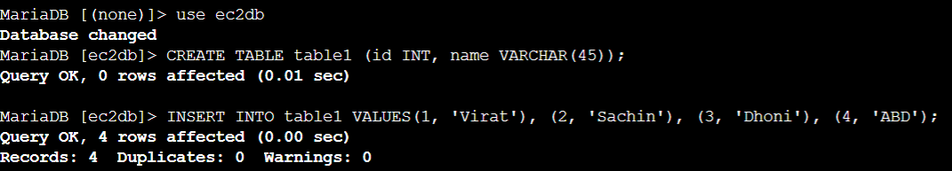

**To see the table1 content we are using “SELECT * FROM table1;”**

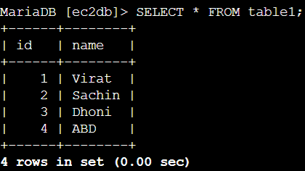

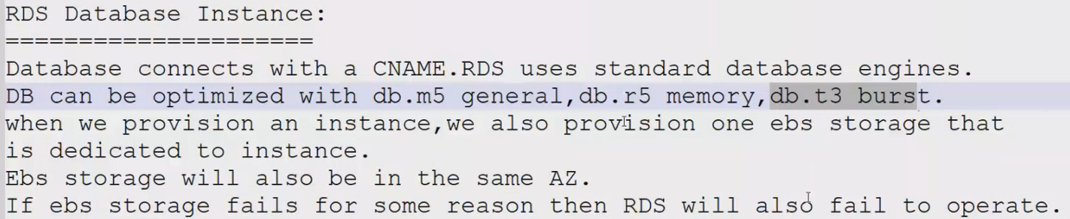

**Creating Database on RDS Instances;**

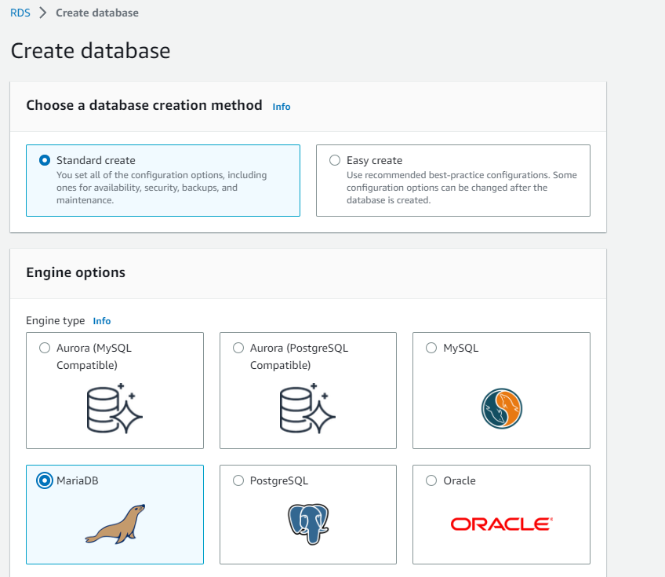

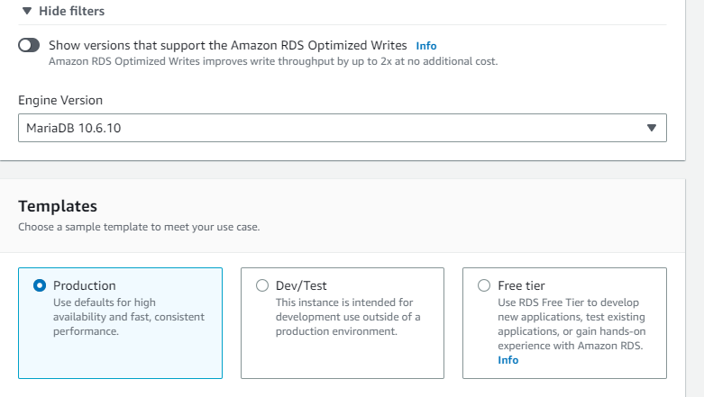

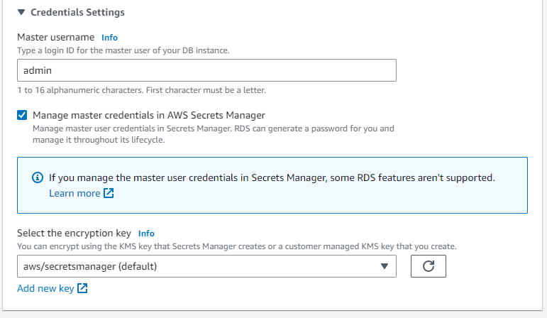

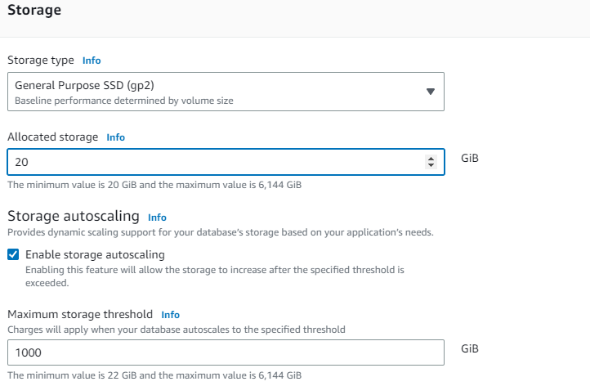

**On Connectivity we have to connect our resources with ec-2**

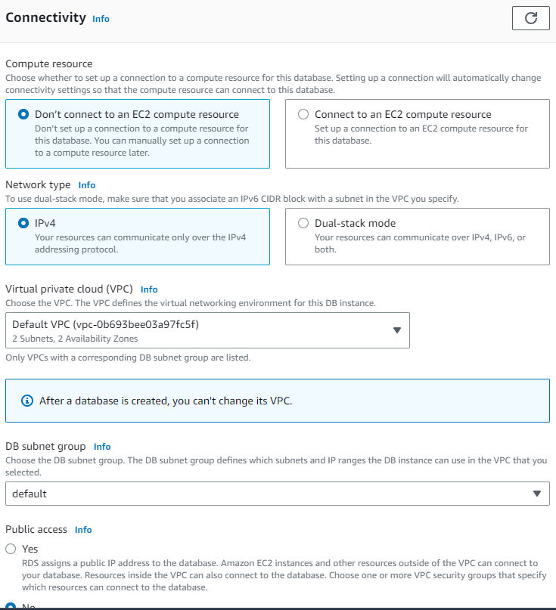

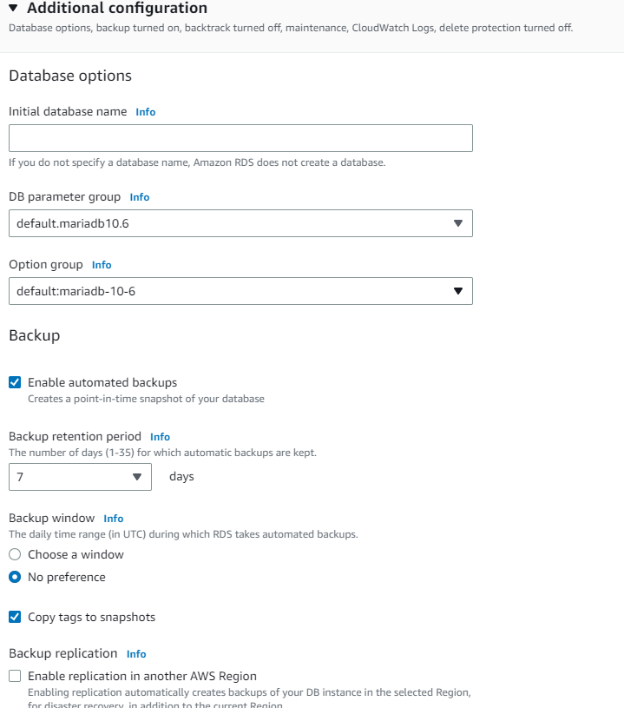

**3. launch Mariadb RDS instance.**

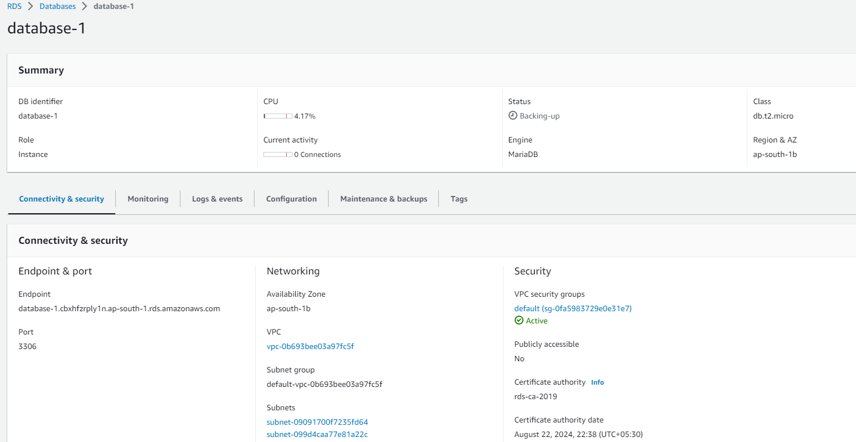

**4. Migrate database from ec2 to RDS.**

* **Get the dump of your existing DB on EC2**

**mysqldump -u root -p database_name > file_name.sql**

* **Migrate the DB dump that you have taken in step 1 to RDS**

**mysql -h <replace-rds-end-point-here> -P 3306 -u <user_name> -p database_name < ec2db.sql**

* **Connect to your RDS DB instance**

**mysql -h <replace-rds-end-point-here> -P 3306 -u rdsuser –p**

* **Switch to the database and verify the details.**

**USE rdsdb**

**SELECT * FROM table1;**

**DUMPING/BACKUP OF EXISTING DB ON EC2;**

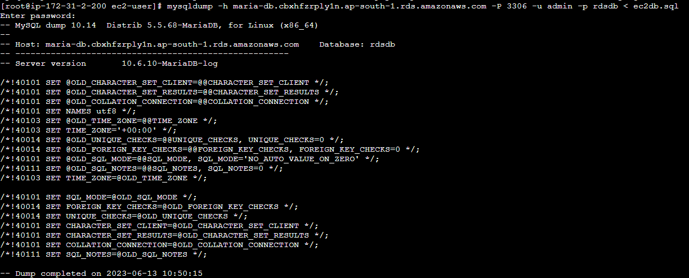

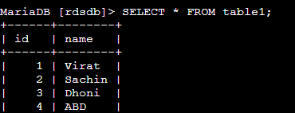

**5. Configuring multi AZ :**

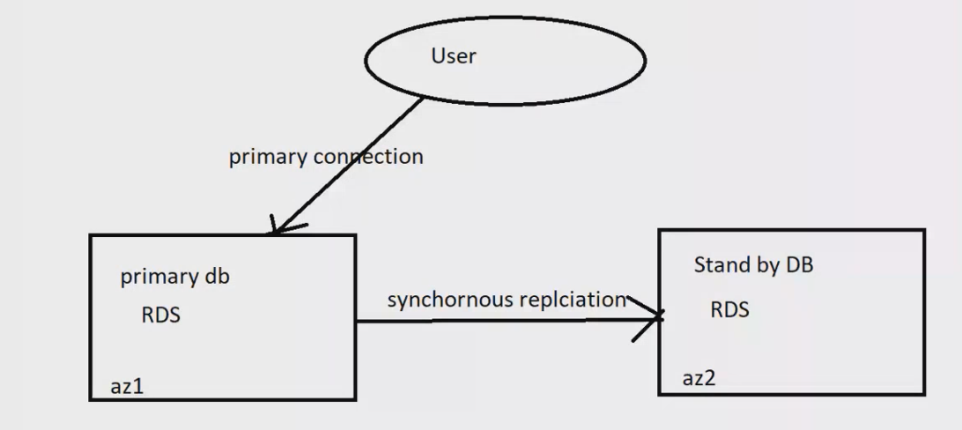

**“It is managed by AWS only”**

**EXPLANATION:**

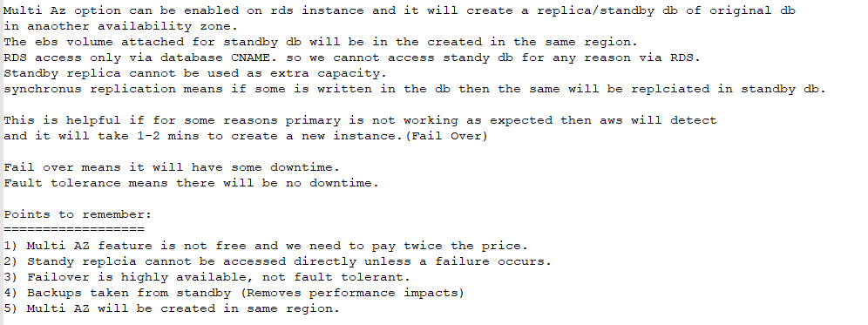

**CREATION:**

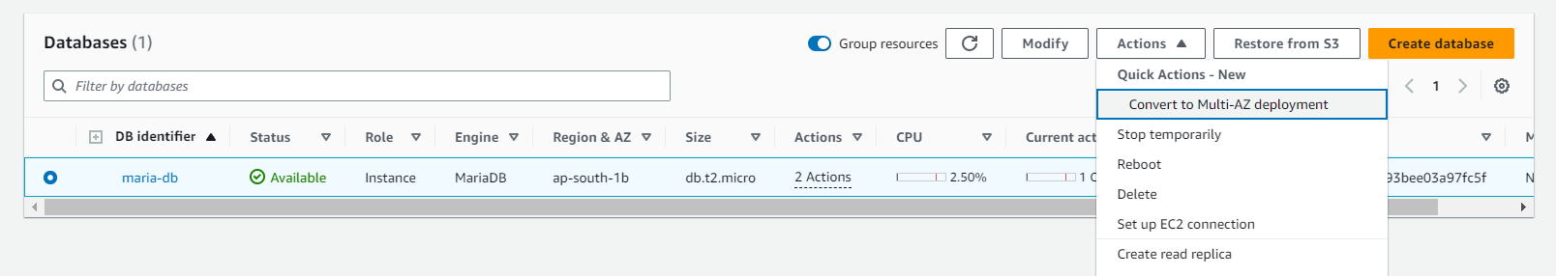

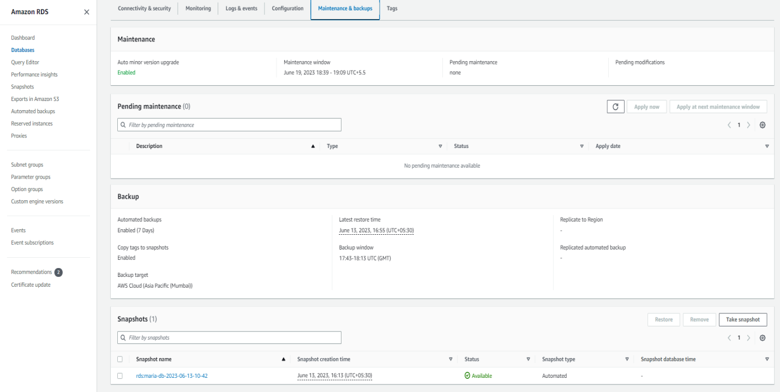

**6. Installing MYSQL db on ec2;**

**Follow the doc for installing mysql in aws ec-2;**[**https://tecadmin.net/how-to-install-mysql-8-on-amazon-linux-2/**](https://tecadmin.net/how-to-install-mysql-8-on-amazon-linux-2/)

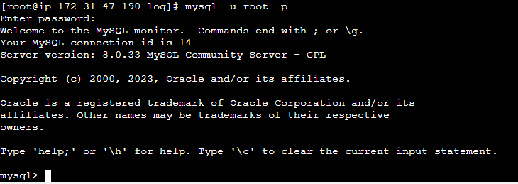

**Inserted some dummy data in mysql ec2/ and taking backup;**

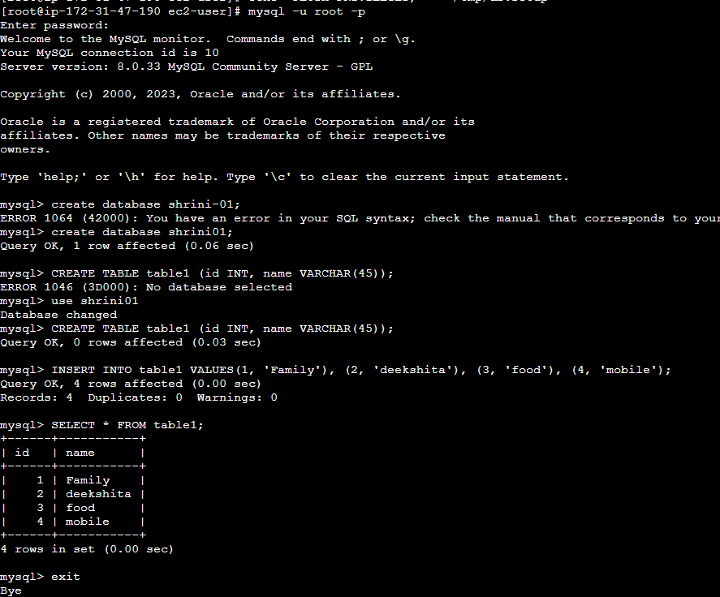

**Now taking backup of above ec-2 db named “shrini01” with SQL file;**

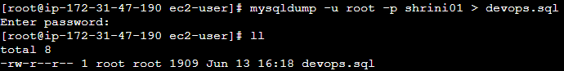

**Password will be given on MYSQL installation will be used here**

**Now, we moved the backup file of ec2-db named “devops.sql” but we have to create a DB inside the RDS-DB named “shrini”;**

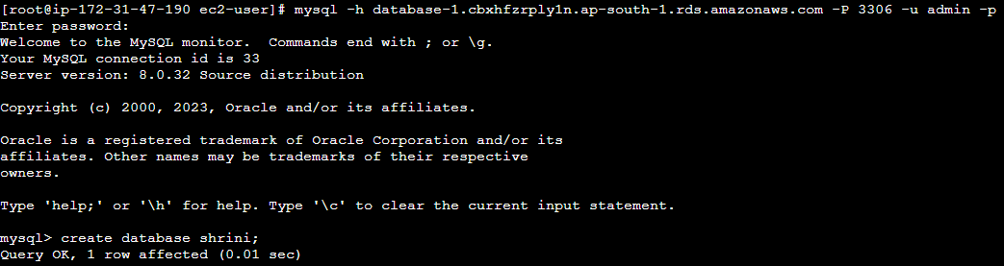

**So DB is created and we have to backup the ec2-DB(shrini01) to RDS-DB(shrini)**

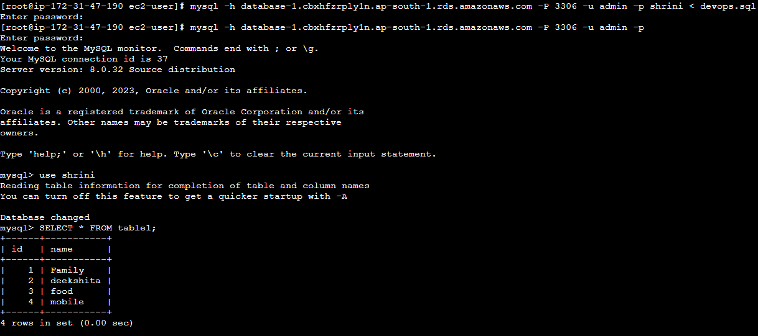

**“Above pic we can see our ec2-db content has been backup in RDS-DB”**

**7. Launching mysql RDS image;**

**We have to follow all the above steps for mentioning in mariaDB RDS just only we have to take the image of MYSQL;**

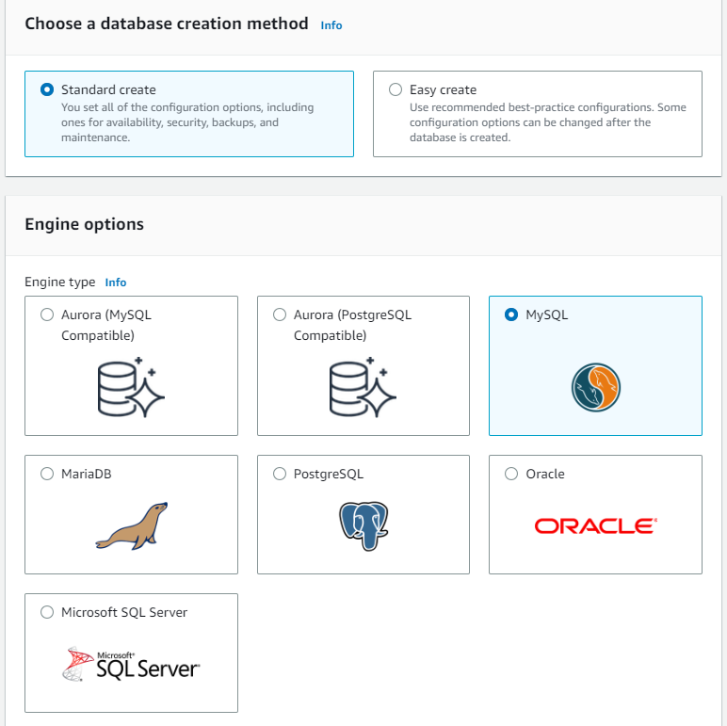

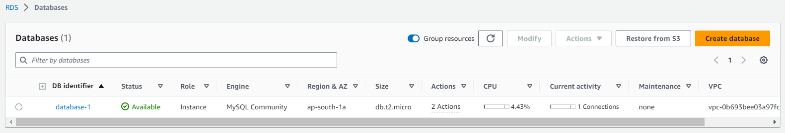

**8. Taking Backup of db via Snapshot;**

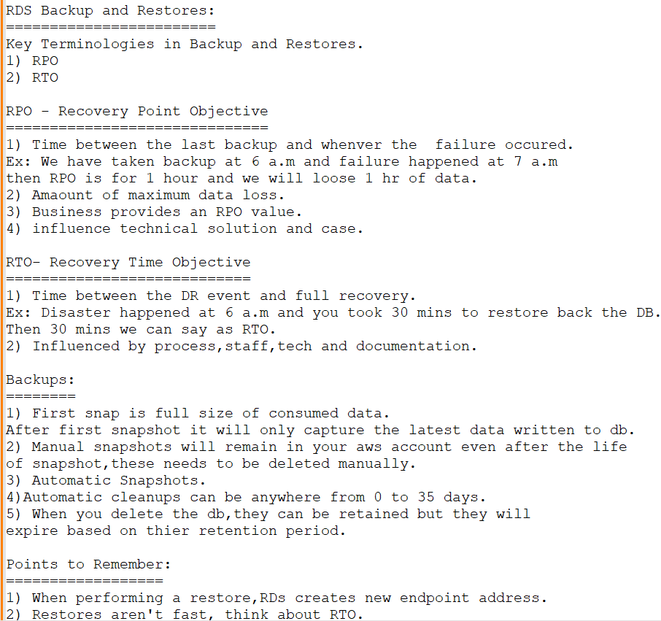

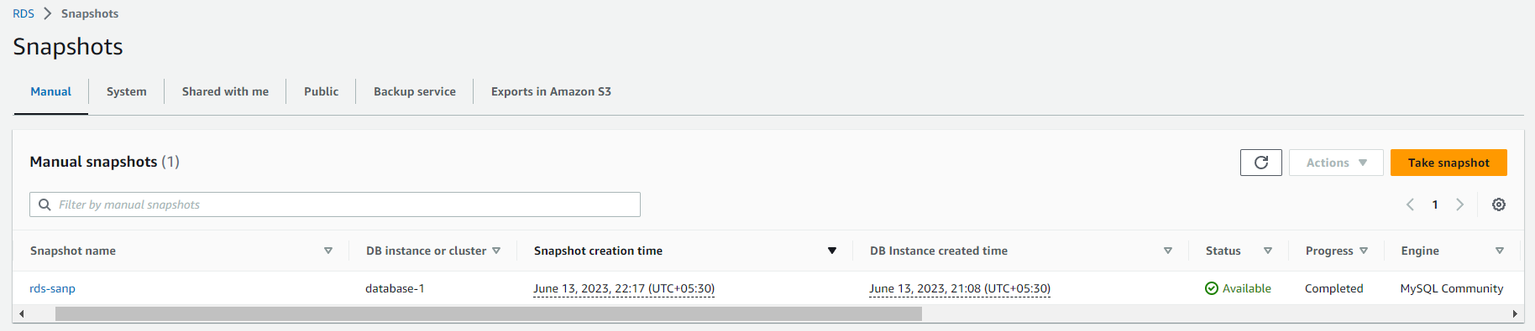

**And Now, we will restore the db after deleting the RDS-DB;**

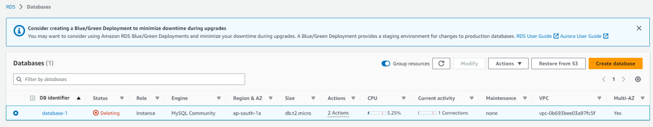



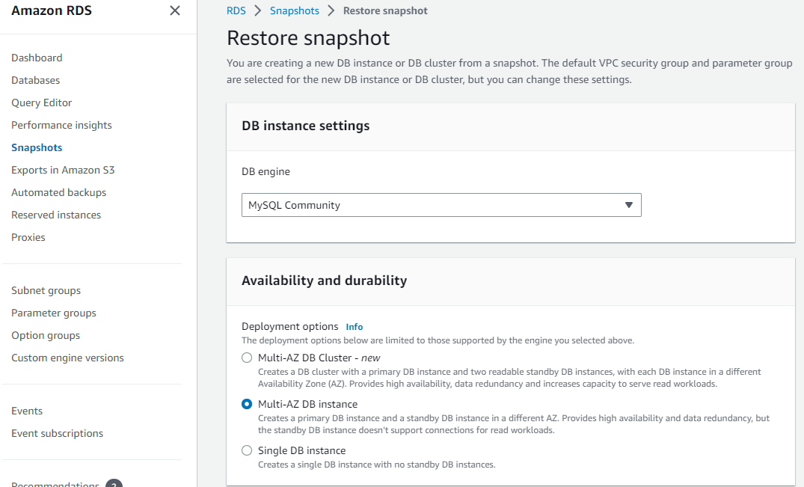

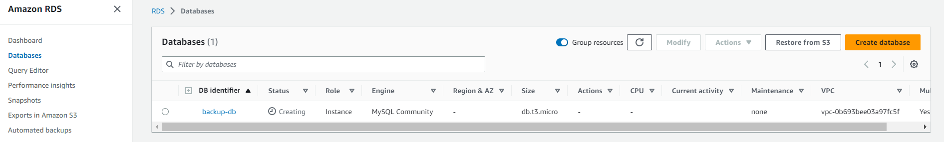

**Now, we have to take our new endpoint and try to connect with ec2;**

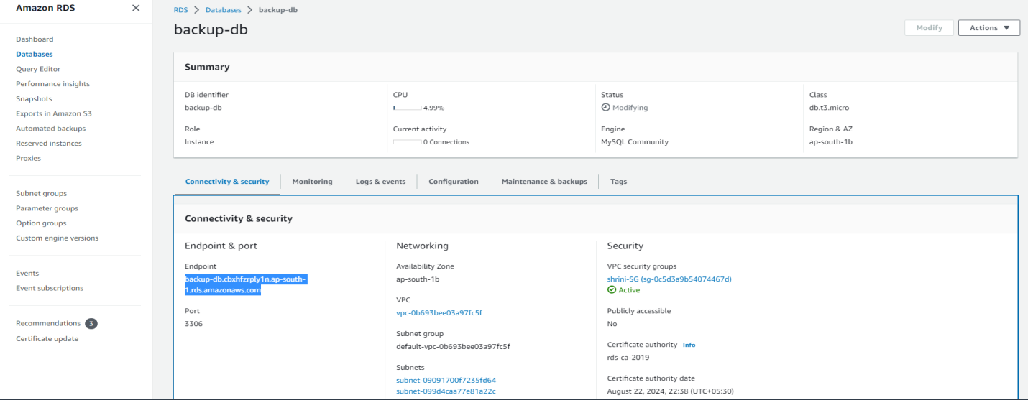

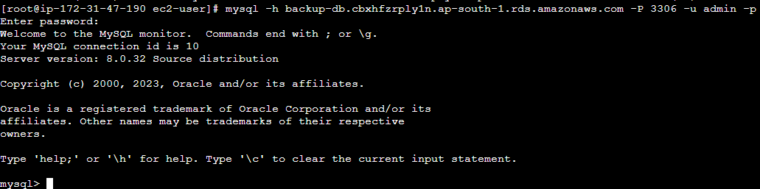

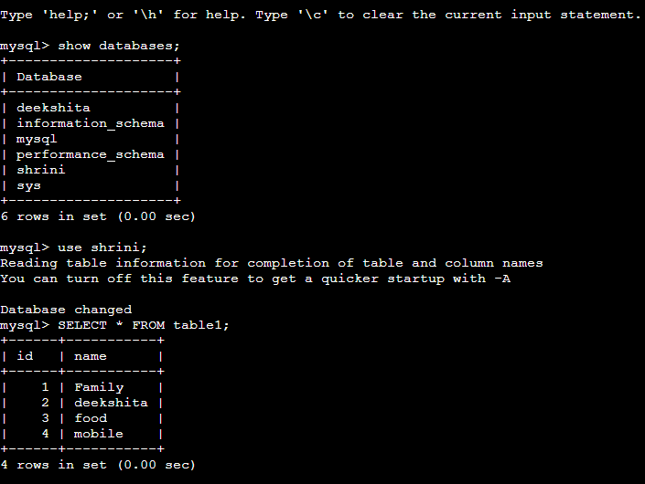

**“By restoring the db we are getting our databases with the help of snapshot”**

**9. Creating Read-Replica;**

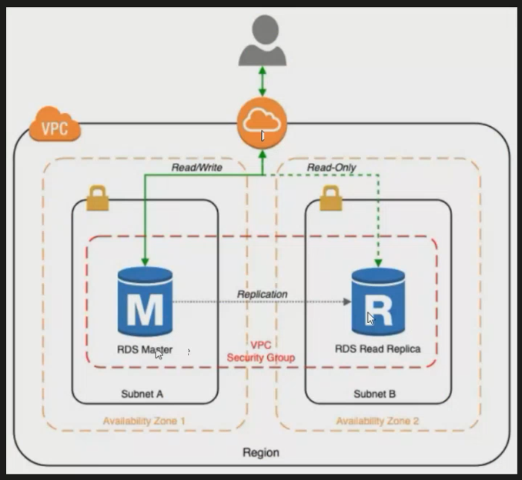

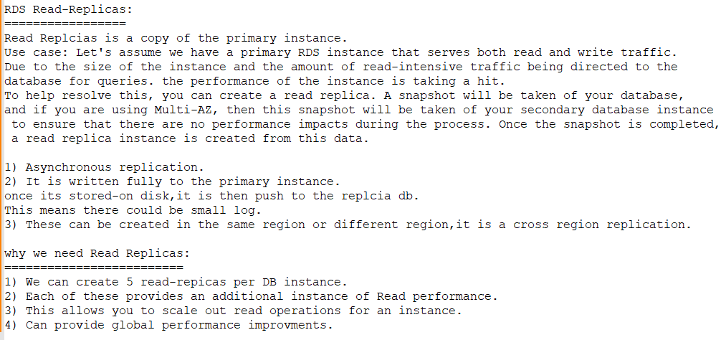

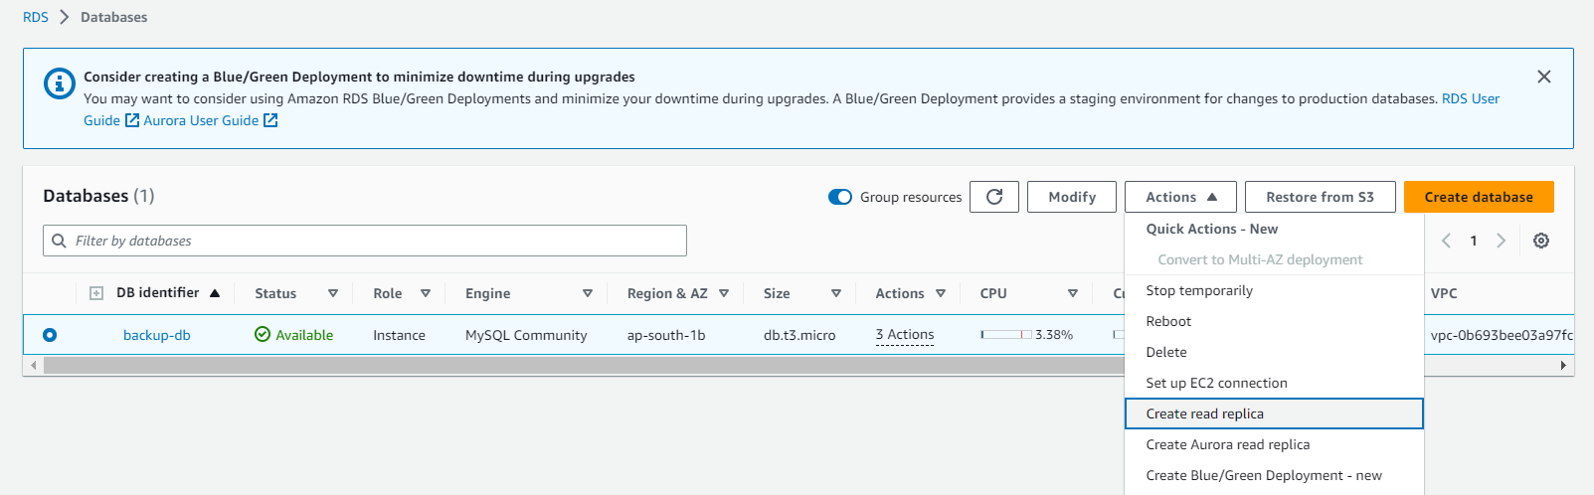

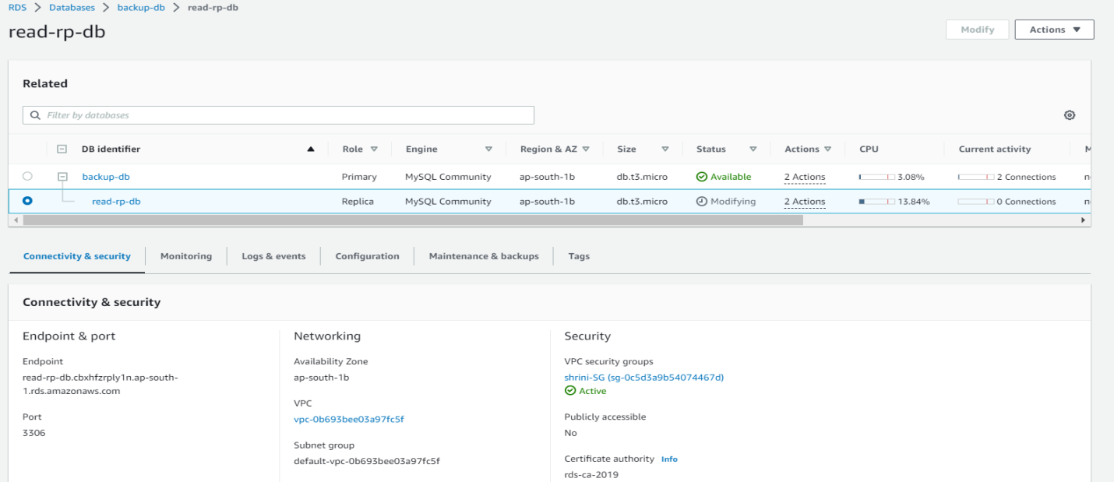

**\*\*If we want to use the read replica-db we have to take endpoint of replica   
“You can find the below error we can’t able to write ant thing on db”**



